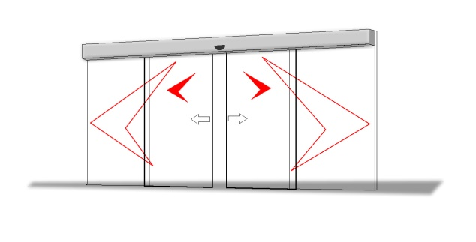

AUTOMATIC DOOR SPECIFICATION | PUBLIC AND DISABLED ACCESS TOILETS
The Automatic Door Operator is to be a fully electric operator housed in an extruded aluminum section (Height 215 mm x Width 135 mm) the unit shall be Australian made by an Australian owned company must and comply to the BCA and all safety aspects of AS5007-2007.

The equipment will incorporate the following

- The equipment will incorporate a DC drive motor with built-in optical sensor for precise movement control and high torque for a maintenance free life.
- The pelmet shall incorporate an integrated and interlocking hinge for secure opening and closure to prevent falling off and incorporate secure mountings to hold in closed position.
- The design shall enable the operator to be fitted flush with the ceiling when required while still enabling the pelmet to be opened fully or removed for maintenance access. A removable panel of at least 400mm width for the full length of the pelmet should be allowed for. Drawing RBK15 OR for a cavity slider door as per drawing RBK45. Standard Bulkhead mounting may also be achieved as per drawing RBK7.
- The multifunctional door operators microprocessor controller shall feature the following:
  - Self-calibrating and programmable via simple internal adjustment. No proprietary external programmers required.
  - Fully adjustable door open and close speed and sensitivity settings to ensure optimal operational efficiency.
  - Fully adjustable open and closed braking speeds.
  - Fully adjustable torque control.
  - Provision for full interfacing with all types of building management, security/alarm and fire systems.
  - Built-in UPS (uninterrupted power supply) for continued operation of door under mains power failure.
- Moving doors will automatically reverse when traveling in either direction if obstructed. Retry setting programmable from 1 to 10 times. Door speed shall be adjusted to comply with maximum speeds set down within AS5007 for specific weight of door.
- As per the BCA, during a total power failure or system malfunction the door and lock shall instantly revert to safe manual operation.

ACTUATION

- The exterior door activation is to be by a push button with separate illumination to indicate Occupied.
- An override key switch is mounted on the outside for emergency access purposes.
- The doors shall be controlled within the toilet enclosure by a push button with separate illumination to show when locked. When pressed to lock, both internal and external Open push buttons should be disabled to prevent accidental door opening. A separate internal Open push button should allow for door opening.

LOCKING

Electric locking is incorporated into the motor drive equipment and ensures total privacy and security. No separate electric latching mechanisms are used as they are prone to fail and do not meet BCA Section D2.19.

MONITORING

The operator controller monitors all aspects of the doors operation, safety and locking and should revert to a safe manual mode if any faults are detected.
Backup battery should raise an audible alarm if the charge circuit cannot maintain a minimum battery working voltage.

INTERFACING

Terminal outputs available for security systems and building management systems to monitor door position and lock status.
Fire connection terminals are provided.

SPECIFICATION
 | Single door
Maximum door weight | 250kg
Opening speed | 200-1000 mm/sec
Closing speed | 100-750 mm/sec
Door open dwell time | 0-30 sec
Manual opening/closing force | ~20 N

MECHANICAL
- Drive should be by Kevlar reinforced toothed belt to ensure quiet operation with a minimum of 1500kg breaking capacity.
- All steel components should be zinc plated as a minimum or powder coated.
- Track should be replaceable in the housing and should hard anodized for lasting protection.
- All wheels must house fully raced bearings and be of hard nylon construction.
- Door hanger brackets should be double bolted to door carriage rails for added safety.

INSTALLATION

The operator shall be installed by the fabricator or glazing company or the authorized service agent to the manufacturer’s recommendations.

WARRANTY

All units are covered by a 2 year parts warranty and a 12 month labour warranty. The housing is covered by a lifetime warranty against manufacturing defects. An extended parts and labour warranty plan can be provided through an optional maintenance agreement if required.

MAINTENANCE

Any service personnel should be able to work service and maintain and make all adjustments to the automatic door operator without the need of proprietary external programmers or other software devices.

PROPRIETARY ITEM

Structural Automatic Door Operator

MANUFACTURER

Rubek Automatic Doors

SAFETY

- Photo electric cells or an internal curtain sensor should be used protect the door and people from possible collision.
- The door operator should allow for backup and retry in case of obstruction.
- The door operator should be self-monitoring to detect any faults.
- The maximum force to manually open the door should not exceed 110N.
- The maximum static force exerted by the leading edge of the door leaf should not exceed 130N.

Note: A separate warning button should also be installed in toilet or parenting rooms that have automatic doors so in the event that a person becomes trapped in the room there is a form of notification to a manned location on the premises.

OPTIONS

Both control plates are available with or without braille. RBK51, RBK52 or RBK37, RBK38, RBK40
MLAK external control plate is available. RBK53

All drawings in CAD format can be downloaded from here

www.rubek.com.au : sales@rubek.com.au

CONTROL PLATES FOR PRIVACY ROOMS

Internal Control Panel |  | 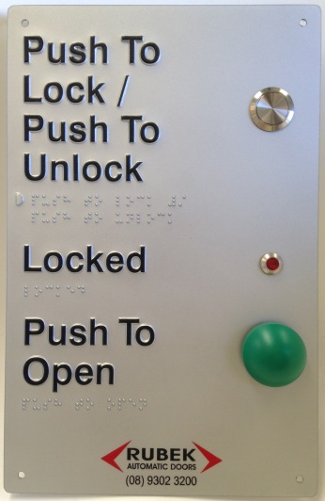
Standard External Control Panel |  | 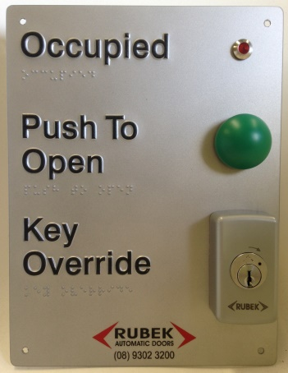
External MLAK Control Panel  (Used in place of Standard panel) |  | 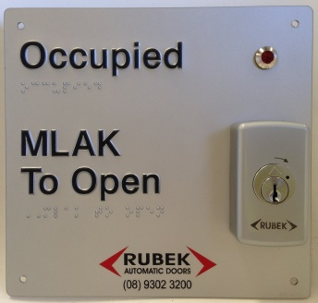

www.rubek.com.au : sales@rubek.com.au

